**Recruiting Advertising Strategy**

**Background**

The Whitman School of Management launched an internet recruiting campaign from February 2011 through December 2014, using Google Ads and Delta Airlines’ flight magazine advertisements. An assessment of opportunities and results is now necessary to establish the direction for a campaign one year from today.

**Resources**

Use Google Analytics to examine the Whitman Graduate Programs internet marketing campaigns. All data can be accessed via Google Analytics. If you have any questions, please send me an email.

**Assignment**

**What’s due:**

Submit an advertising analysis **before the live class in week 6**. Suggested length is 5 pages but should not exceed 10 pages, single-spaced, 12-point font.

Use Google Analytics to analyze the data to identify patterns and opportunities. Your goal is to recruit the best United States students, measured by GMAT scores, but you are limited to a budget of $100,000. The budget must cover advertising costs, but no Whitman administration costs. The campaign starts one year from today.

This is a group assignment; each student should upload a copy of the assignment to the learning management system. The paper must be a Microsoft Word document. Name the file HW2_Team# where # is your team number. Be sure to include the names of everyone on the team on the first page of the paper. Late assignments will not be accepted. Failure to follow directions will be penalized.

**Outline and grading criteria:**

1. What were the time frames for each marketing campaign? How much was spent on each campaign? What was the effectiveness of previous campaigns? Create a table listing campaign, start date, end date, cost, and all other measures listed in Google Analytics. Discuss the effectiveness of each campaign. (40%)
   1. whitman.syr.edu
   2. MBA Marketing – iMBA
   3. MBA Marketing – Full-time
   4. Delta (cost of one-month quarter page ad was $10,000)

Between the years 2011-2013, Syracuse University launched several marketing campaigns for their MBA Master’s program. Syracuse University launched a total of four different campaigns, each taking place within a different timeframe and exhibited different behavior that influenced our marketing strategy for 2023. Below are our findings after conducting our initial analysis on four separate marketing campaigns. A brief outline of our findings will be explained below and our analysis will be attached.

**Whitman Campaign**:

The Whitman campaign started on February 26, 2011 and ended on August 24, 2011. During this timeframe, google analytics provided insight on the overall effectiveness of this specific campaign measured by the following metrics: Clicks, Campaign Cost, Cost per Click, Number of Sessions, Bounce Rate and Pages per session. The Whitman campaign had a total of 9358 clicks, a total campaign cost of $37,699.45, a cost per click value of $4.03, 7080 different sessions, a bounce rate of 78.39%, and a value of 1.83 pages per session. The Whitman campaign appears to be the most successful of the Google Ad campaigns. This campaign received the most clicks and hosted the most sessions by a significant margin; however, this data may not be totally adequate for our analysis. We did not exclude users from within the University. This means that every computer in the Whitman building or anywhere on campus with this page as its homepage collects session and click data whenever a student uses it. We do not know for sure whether this is the cause of the huge gap but this leads us into another key metric; bounce rate. If many users had this page as their homepage when visiting, the bounce rate should probably be the highest of all campaigns, yet in our case, it is the lowest. In conclusion, the Whitman Google Ad campaign received the most clicks and sessions while maintaining the lowest bounce rate resulting in the most successful Google Ad campaign.

**iMBA Campaign**:

Syracuse’s iMBA campaign started on February 2, 2012, and ended on October 26, 2012. This campaign had the following values measuring its overall effectiveness: 5818 total clicks, total campaign cost of $80,663.24, a cost per click value of $13.86, 2625 different sessions, a bounce rate of 89.22% and averaged 1.14 pages per session. The iMBA campaign performed the worst. The cost was the highest, sessions and bounce rate were the worst among the Google Ad campaigns.

**Full Time Campaign**:

The full time MBA campaign started on October 26, 2012 and ended on July 1, 2013. This campaign resulted with 4320 total clicks, a total campaign cost of $71307.56, a cost per click value of $16.51, 4285 different sessions, a bounce rate of 82.50%, and a value of 1.27 pages per session. The full-time MBA campaign managed to get better results than the iMBA campaign at a lower cost. They received less clicks, yet the sessions far exceed that of iMBA. The bounce rate was also lower.

**Delta Magazine Campaign**:

The Delta Airlines magazine campaign was slightly different from the other three campaigns, but still produced some interesting results that facilitated our marketing strategy. The campaign started on October 1, 2013 and ended on October 31, 2013. The total cost of the campaign was $10,000.00, had a total clicks of 19, a cost per click value of $526.32, 19 different sessions, a bounce rate value of 43.37%, and a value of 2.65 for pages per session. Being that the internet is available to almost everyone and Delta magazines are available to a far smaller population, the clicks and sessions are expected to be lower. The bounce rate and pages per session were the best of all campaigns by a significant margin. The bounce rate was twice as good as iMBA’s. I believe we can credit this to the user’s intrigue and initiative. By this I mean that if someone is flipping through a magazine and is interested enough to pull out their phone or laptop and type in an entire url, they are probably already very interested in what that site has to offer resulting in a more thorough browsing.

Below is Figure 1, which highlights the measures of effectiveness by campaign. Additionally, our team formatted each field in the excel spreadsheet to visually depict which campaign had the best value per measure of effectiveness.

Figure 1 – Measures of Effectiveness by Campaign



1. Create a prediction of cost per click and a prediction of advertising cost per student for Google Ads for next year (a year from today’s date). Use either the prediction technique or Excel’s forecast option. Do not include Delta. If using the forecast option, assume the years below. Number of students recruited from the advertisements is listed below. (10%)
   1. whitman.syr.edu (2011 – 50 students enrolled)
   2. MBA Marketing – iMBA (2012 – 24 students enrolled)
   3. MBA Marketing – Full-time (2013 – 15 students enrolled)

After reviewing the data points for the four different marketing campaigns, our team created a forecast to predict the cost per student for the year 2023. Team 72 accomplished this by determining the cost per student for three of the campaigns (Whitman, iMBA, and Full Time). We accomplished this by dividing the total campaign cost by how many students were enrolled. In 2011, the Whitman program enrolled a total of 50 students into the program. In 2012, the iMBA campaign resulted in enrolling 24 students. Lastly in 2013, the Full-Time campaign resulted with enrolling 15 students into the program. We took those values to determine the advertising cost per student for each of the campaigns. Based on our forecasting results, the forecasted advertising cost per student in 2023 is expected to be $25343.19 and the forecasted cost per click for 2023 is expected to be $82.40. Figures 2 through 5 below visually depict our findings:

Figure 2 – Cost Per Student Forecast in Table Format

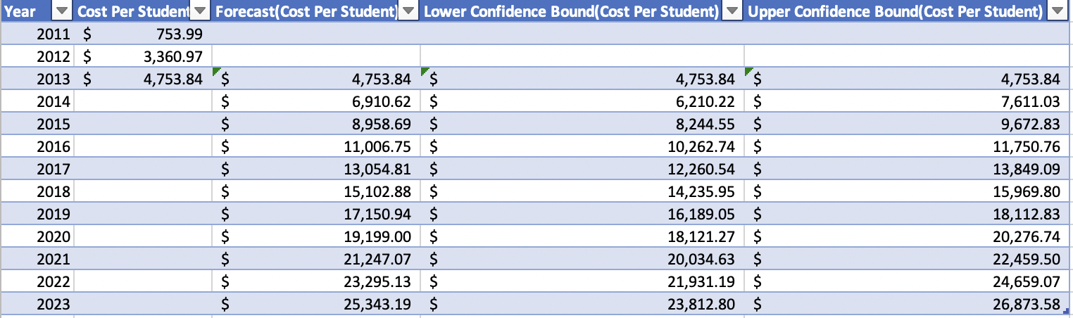

Figure 3 – Forecast in Graph Format

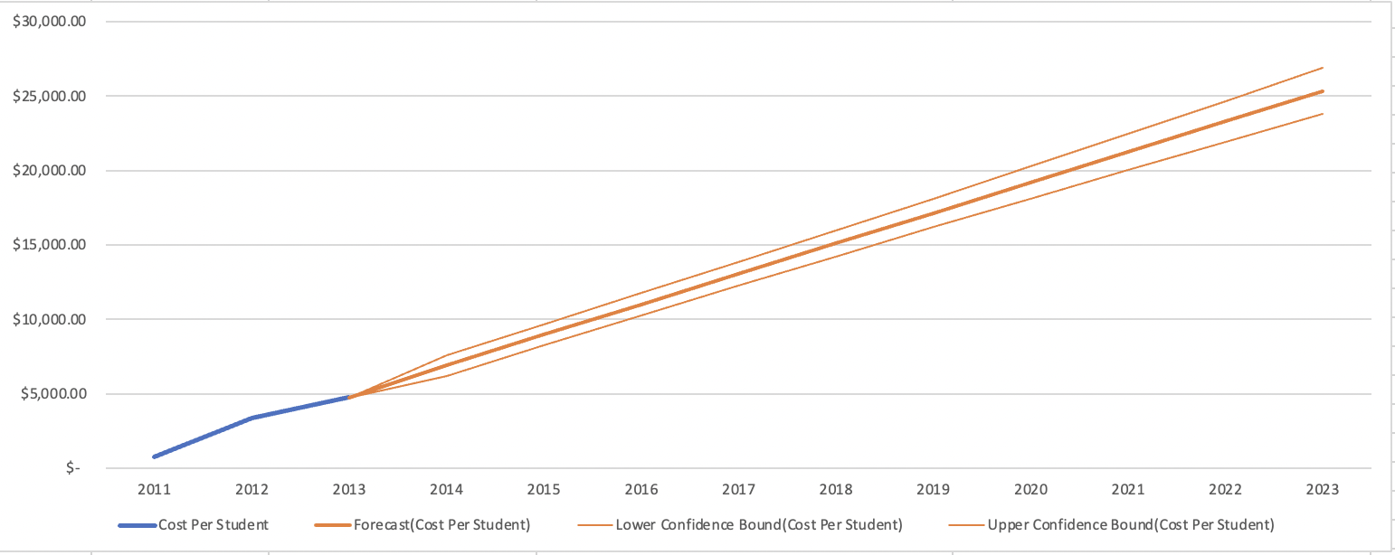

Figure 4 - Cost Per Click Forecast in Table Format

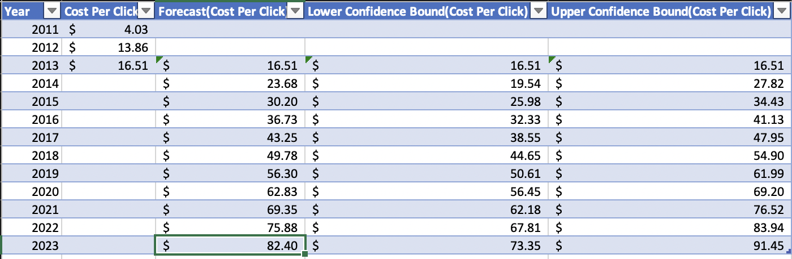

Figure 5 - Cost Per Click Forecast in Graph Format

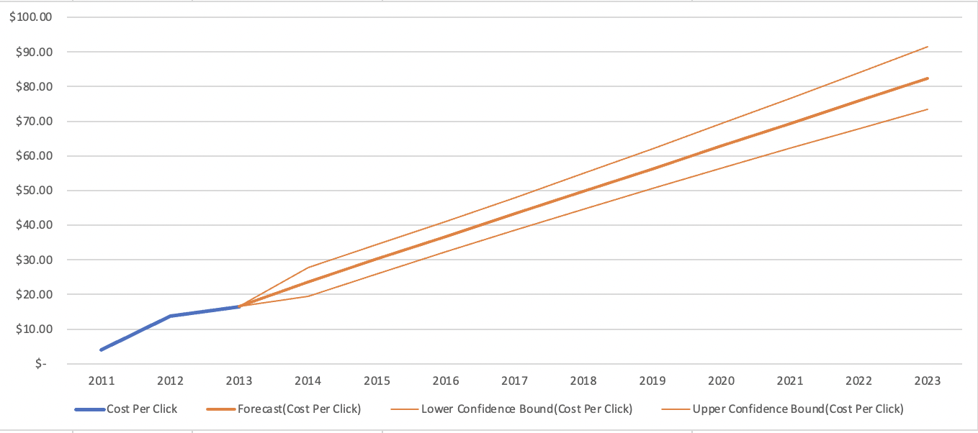

1. Identify the key aspects of a United States campaign for next year. (20%)
   1. In which geographic region, states, or cities would you advertise? Why?

We were given a budget of $100,000. Based on our forecast, the cost per click in 2023 will be $82.40. This gives us about 1,213 clicks to use for an entire year and 23 clicks each week and 3 clicks per day. It is important to note that the amount of clicks per day fluctuates based on how many days we want to advertise each week.  Since our number of clicks is so small, we have to ensure that they are being put to good use. This means when selecting our campaign location, we must put more emphasis on bounce rate, pages per session and duration while maintaining a reasonable amount of traffic. We are recommending advertising in Virginia. This is due to the response rate and effectiveness of previous campaigns in Virginia as well as current website traffic from that region in general. Virginia responded positively to all 3 of our previous campaigns landing in the top 10 in number of sessions. In the most successful campaign (Whitman.syr.edu), the city of Arlington, Virginia displayed some ideal numbers we were looking for. The city ranked 11th in number of sessions with 1,167, 63% of users were new users which was above the average of 56%, the bounce rate was 37.5% (avg. 47.1%), pages per session came out to 4.62 (avg. 3.81) and session duration was 3:36 (avg. 2:58). We then looked at website traffic within the last year and noticed Virginia ranks the highest in number of sessions as well as percentage in new users. This signals a rising popularity here. The bounce rate was also extremely low at 4.55%. We would have to dive deeper into why the pages per session and average session duration are low but we do see a great amount of potential here. The historical marketing campaigns results are shown below in addition to current traffic.

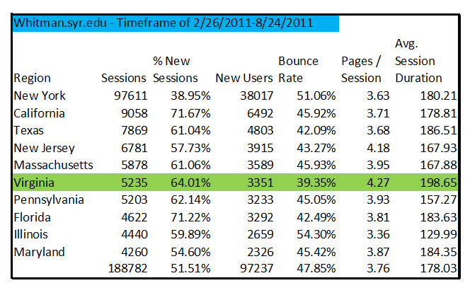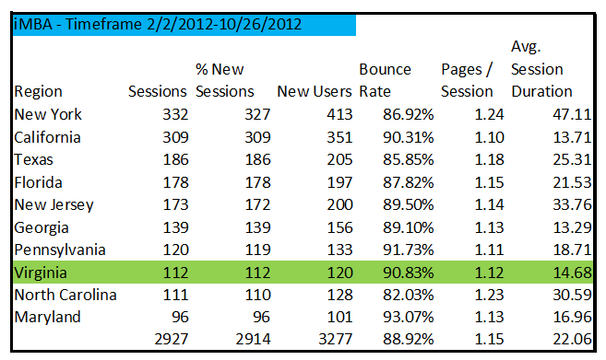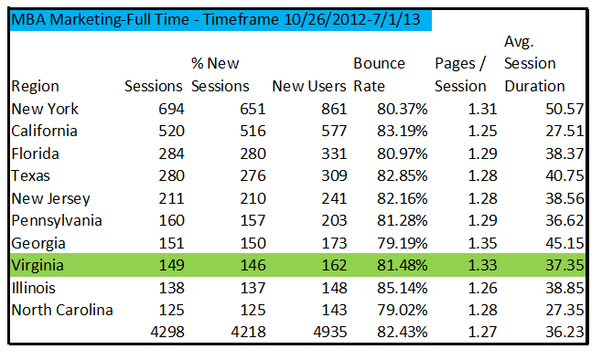

1. What keywords would you use? Why?

**Online MBA** because previous campaigns have proved it to generate the most clicks. Additionally, with our society gravitating more towards remote learning, we believe it can be even more successful than prior years. Keyword results are shown below to justify our decision:

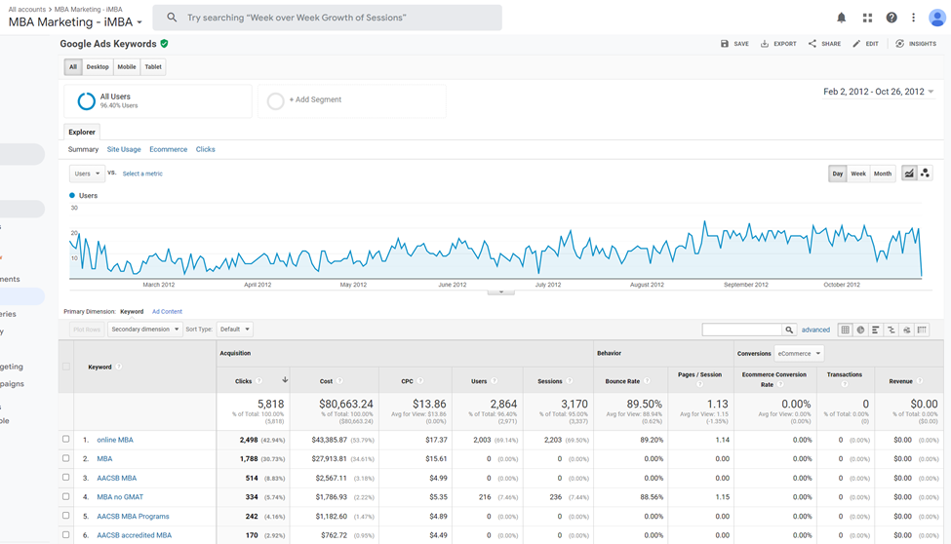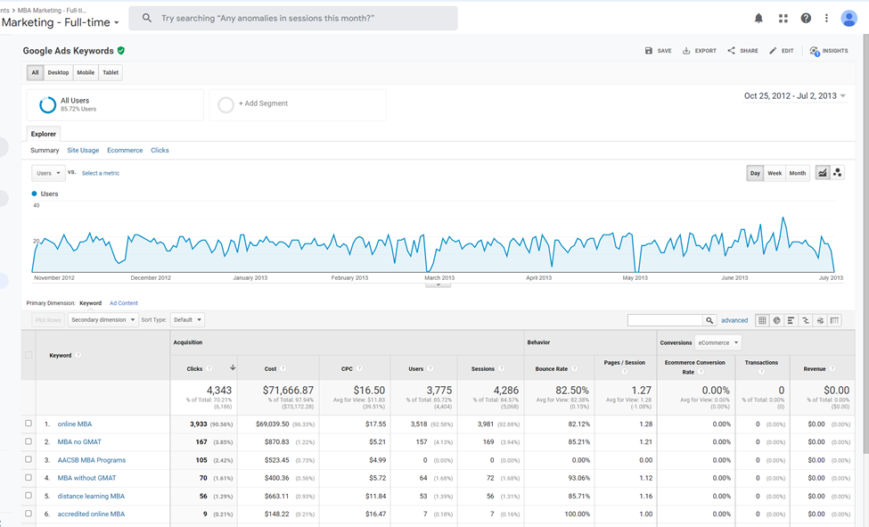

1. Which days of the week and what time of day would you advertise? Why?

Team 72’s marketing campaign will prioritize advertising on Saturdays and Sundays. The time of day we would advertise is 5:00PM to 10:00PM. Given our budget of $100,000 and our forecasted cost per click amount of $82.50, this provides us about 1,214 clicks to use for an entire year, 23 clicks each week and 11 clicks per day since we are advertising on 2 days only. By only advertising on these two days, we expect to maximize our cost per click value by allowing users to view the advertisement during high traffic windows. Ultimately, our group recommends this window as our primary advertisement window because google analytics provided insight that the previous three campaigns received the most traffic within this timeframe. Furthermore, we believe that advertising past 11pm is not worth allocating funds to. This can be explained by the likeness of American society typically resting at this time.  Data from previous campaigns are shown below which displays a similar hour/day trend:

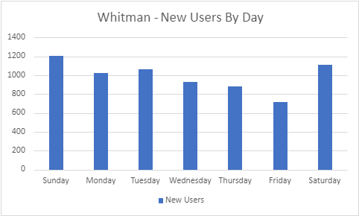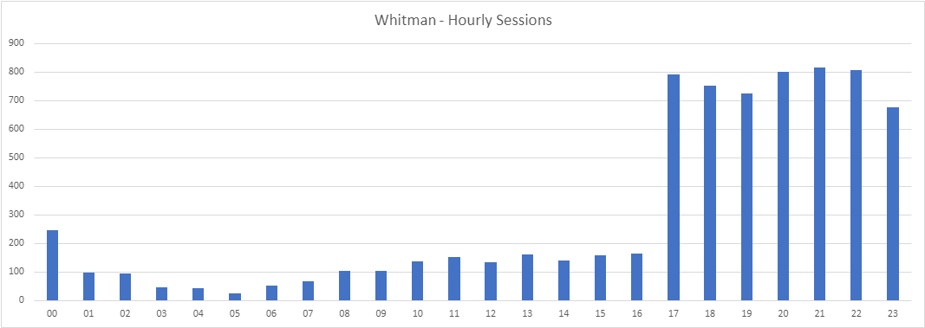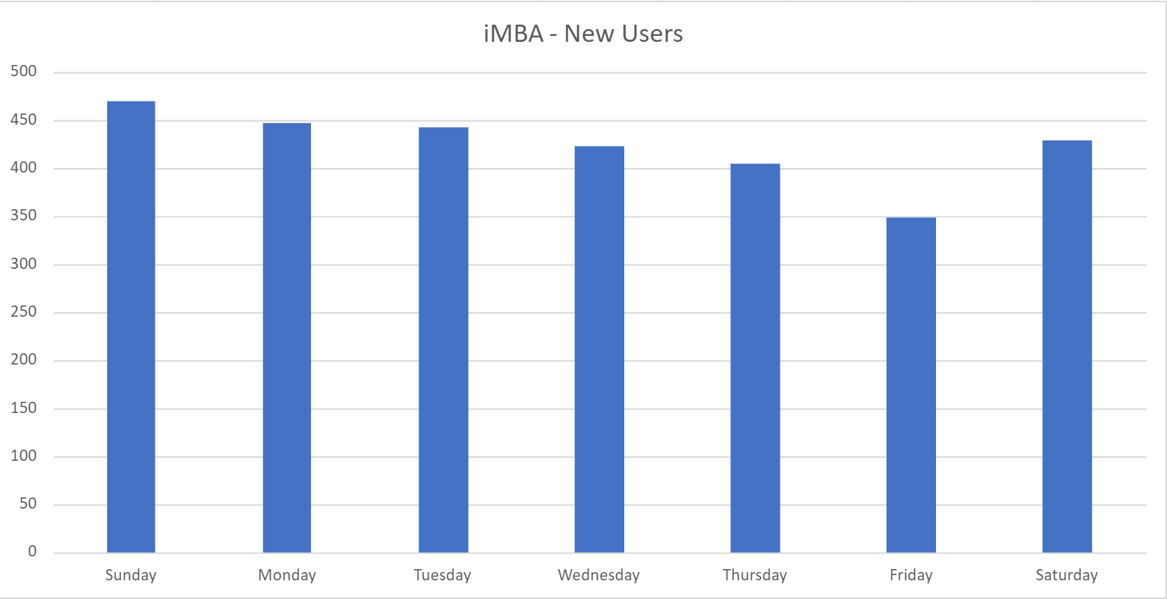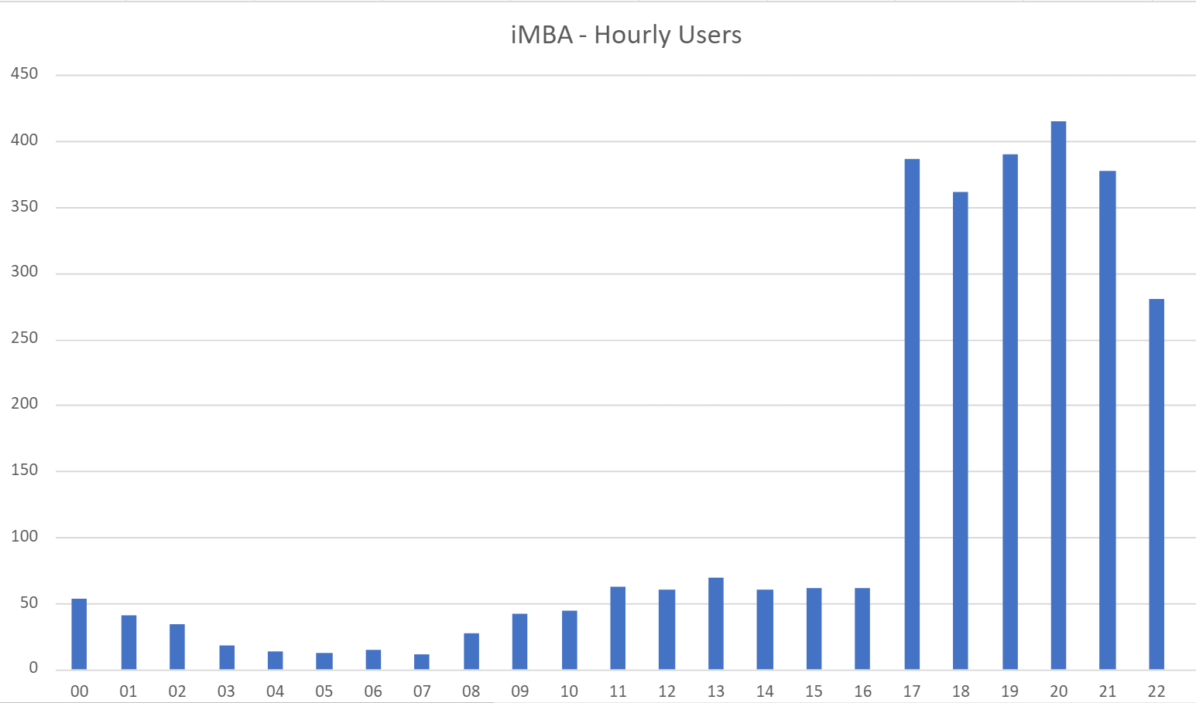

|  |
| --- |
|  |

1. How would you measure performance of your decisions after implementation? (20%)

The goal for our campaign is to recruit the top American students with the highest GMAT scores into the program. Team 72 will be able to determine overall campaign success by analyzing the GMAT scores of all the applicants enrolled as a result of the campaign and compare that data against GMAT scores of students enrolled in prior years.  In addition, we would need to be able to determine the geographic location of enrolled students, both new from the campaign and currently enrolled to determine if we have seen an increase in enrollment from the Virginia area.  We believe understanding these two measures of effectiveness is the best approach to determine overall success of the campaign because it directly answers our primary campaign objective of recruiting the top American students based on GMAT scores. Unfortunately, Team 72 did not have this type of information to support our marketing strategy. This forced Team 72 to rely solely on the data provided by Google Analytics and provided insight on what type of data is required for future campaigns.

1. What other factors or considerations are important? What other data would help in developing an internet advertising strategy if you could collect it? (10%)

Team 72 acknowledges that other data is required to maximize our marketing strategy with a limited budget. We believe having access to GMAT scores of undergraduate students by geographic location will help us target the correct audience.  Without GMAT data being available before the paid google ads are set up, we risk that the clicks that are generated from the campaign may not be lucrative.

We also feel that targeting students with high GMAT scores may not be the route the University should take.  GMAT scores alone are not a predictor of student success and graduation.  Team 72 recommends conducting a case study that follows a cohort from admission to graduation focusing on student performance related to GPA and other factors to confirm if there are other factors besides GMAT scores a marketing team should consider. The results of this case study would either reinforce that GMAT scores are a good indicator for recruiters to look for, confirm if there are multiple characteristics to consider, or suggest that GMAT scores have no measurable metric that indicates how successful a student will be in the program.

Another factor that should be considered when deciding on an advertising campaign strategy is to evaluate what other outside factors could affect responses to the campaign.  An example is that Syracuse has additional campuses in Washington, D.C. and Los Angeles which will create natural attraction and awareness towards the University.  It would be difficult to determine if those outside factors played a role in the recruitment of students or if recruitment was directly related to the advertising campaign alone.